

Dr. Christina, Cook inc.

2024-06-22

Dr. Cook

020 Grant Rapid, West Angelaview, PA 70094

Phone: 7214332285

Fax: 4461954172

**Re:** Maria, Reed

**PHN:** 3537151518

**Birthdate:** 18-Apr-1973

**Address:** PSC 1908, Box 6892, APO AE 20908

**Patient number:** 7034786366

To Whom It May Concern:

This is a medical letter to state the above patient is pregnant with expected delivery date of 25-Apr-2025. Hoping this information is satisfactory for your requirements.

Thank you.

Sincerely,

Dr. Christina, Cook

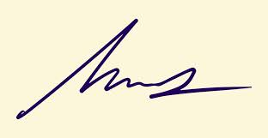

FRCS© NCMP

Clinical Assistant Professor, UBC

Department of Obstetrics and Gynecology SMH